Practical No. 8
Aim: Write a program to find minimum cost spanning using Kruskal’s algorithm.
Software Requirements: Python IDE, Pycharm, Visual Studio Code, Jupyter Notebook
Theory:
- Introduction:
Kruskal’s Algorithm is a greedy algorithm used to find the Minimum Cost Spanning Tree (MST) of a connected, weighted, and undirected graph. It selects edges in increasing order of weight while ensuring that no cycles are formed, ultimately connecting all vertices with the minimum possible total edge weight.
Working of Kruskal’s Algorithm:
1️. Sort All Edges
- Arrange all edges in ascending order based on their weight.
2️. Initialize Parent & Rank Arrays (Union-Find)
- Each vertex is its own parent initially (used for cycle detection).
- Rank array helps in optimizing union operations.
3️. Process Each Edge (Smallest First)
- Pick the smallest edge.
- Use Find-Union to check if it forms a cycle:
  - If no cycle, add it to MST.
  - If cycle, skip it.
- Repeat until the MST has V-1 edges.
4️. Output MST and Its Cost
- Print the edges in MST.
- Calculate and print the total cost.
Program:
class Graph:
def __init__(self, vertices):
self.V, self.edges = vertices, []

def add_edge(self, u, v, weight):
self.edges.append((weight, u, v))

def find_parent(self, parent, i):
if parent[i] != i:
parent[i] = self.find_parent(parent, parent[i])
return parent[i]

def union(self, parent, rank, x, y):
root_x, root_y = self.find_parent(parent, x), self.find_parent(parent, y)
if root_x != root_y:
if rank[root_x] > rank[root_y]:
parent[root_y] = root_x
else:
parent[root_x] = root_y
rank[root_y] += rank[root_x] == rank[root_y]

def kruskal_mst(self):
self.edges.sort()
parent, rank, mst = list(range(self.V)), [0] * self.V, []
for weight, u, v in self.edges:
if (root_u := self.find_parent(parent, u)) != (root_v := self.find_parent(parent, v)):
mst.append((u, v, weight))
self.union(parent, rank, root_u, root_v)
if len(mst) == self.V - 1: break
print("Edges in MST:", *[f"{u} -- {v} == {w}" for u, v, w in mst], sep="\n")
print("Minimum Cost:", sum(w for _, _, w in mst))

V = int(input("Enter number of vertices: "))
g = Graph(V)

print("Enter adjacency matrix (use 0 for no edge):")
for i in range(V):
for j, w in enumerate(map(int, input().split())):
if i < j and w: g.add_edge(i, j, w)

g.kruskal_mst()

Output:
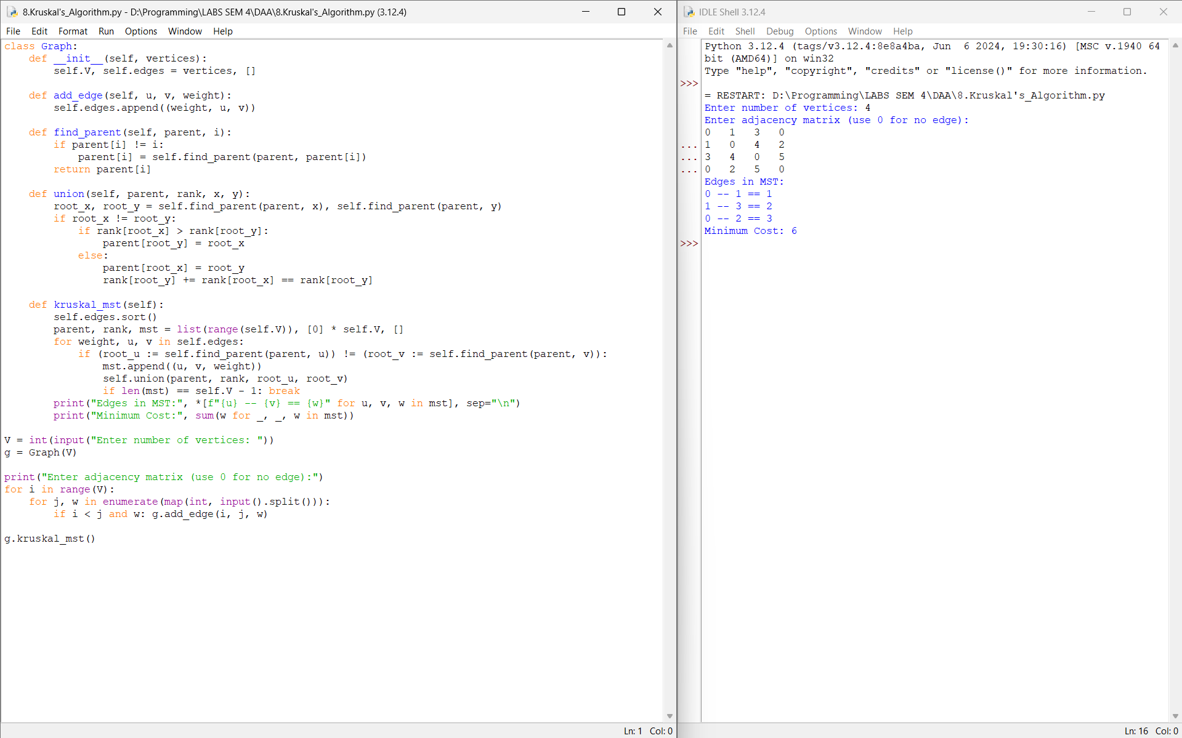
Conclusion:
Hence, I have executed the python program to find minimum cost spanning using Kruskal’s algorithm.

